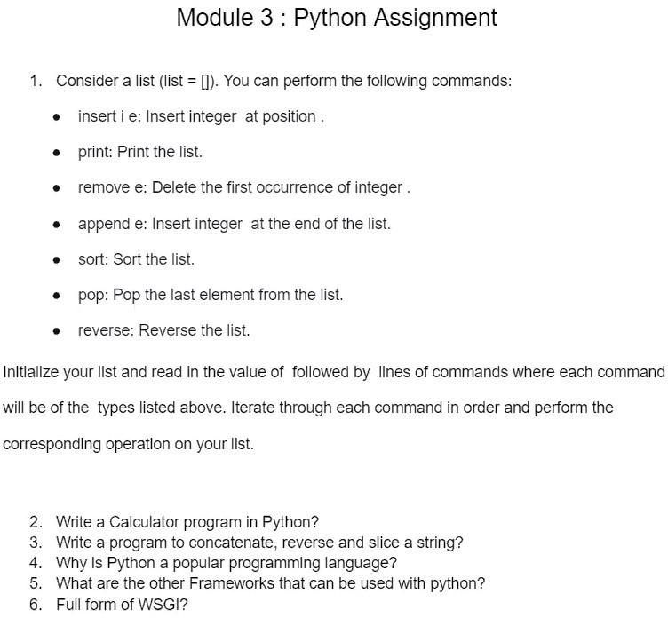

Answers:

Listoperations

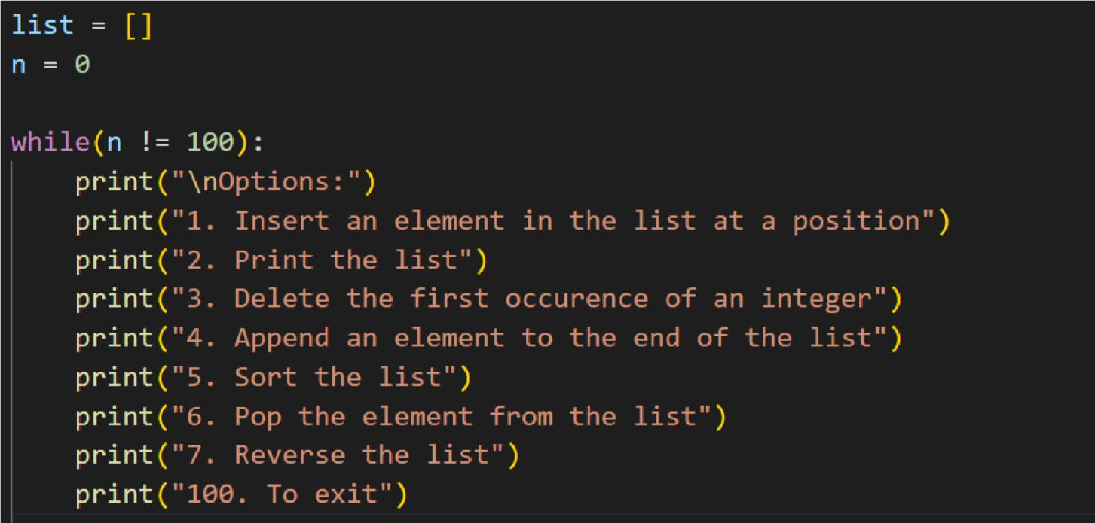

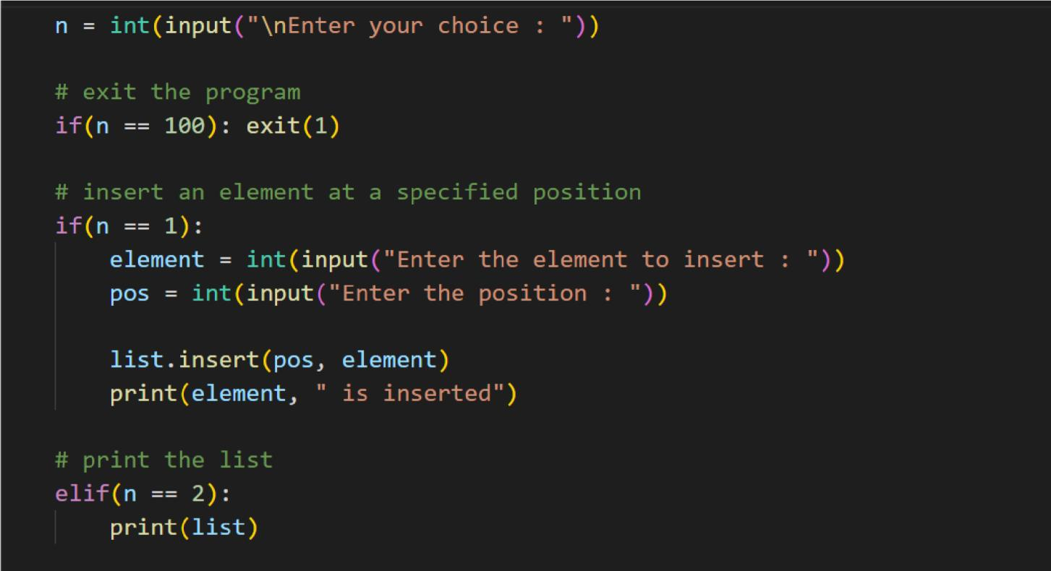

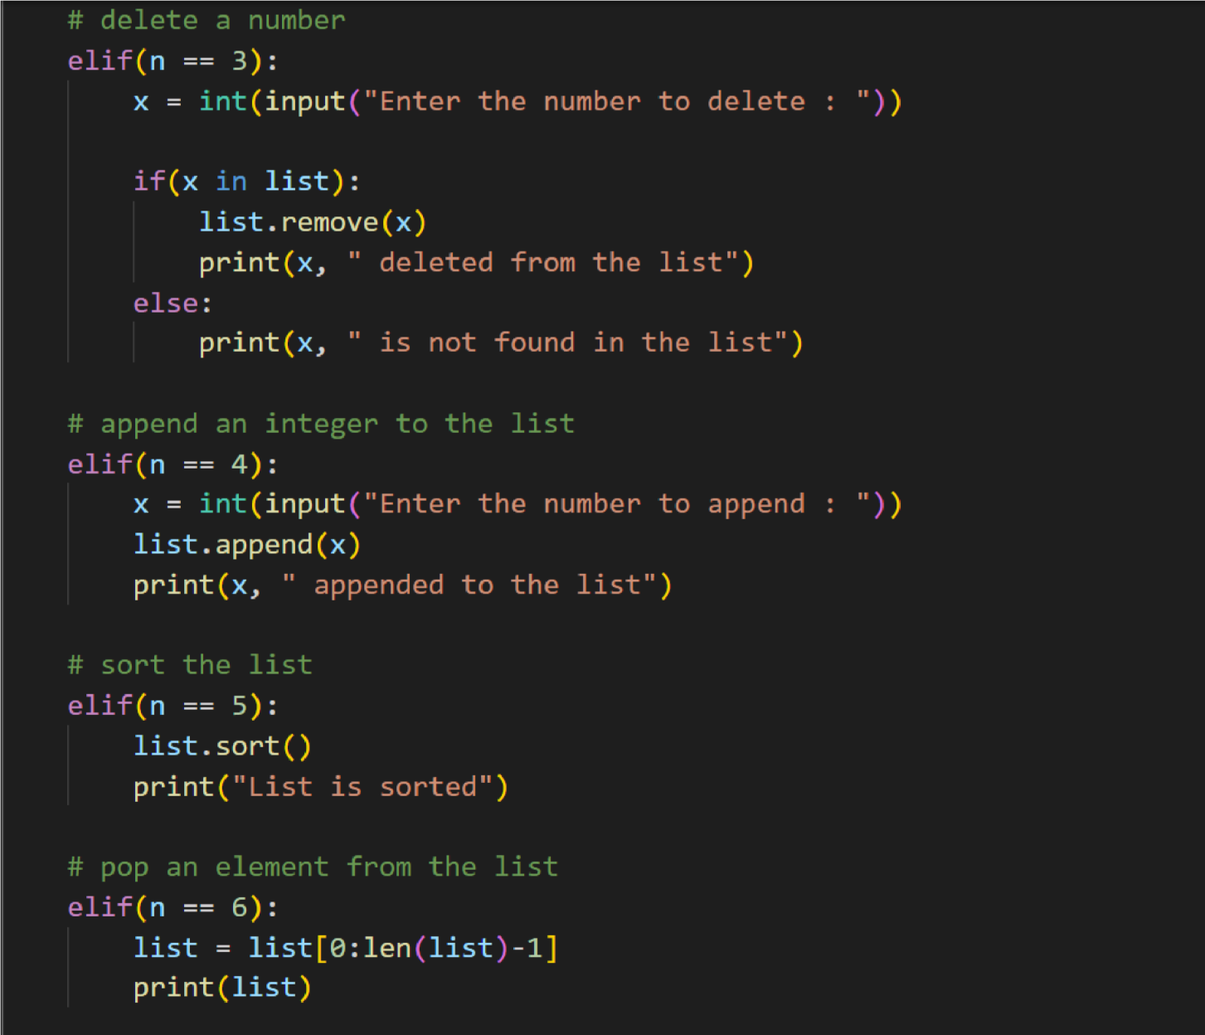

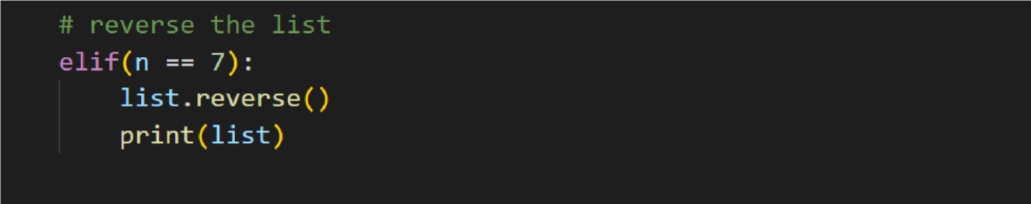

Output:

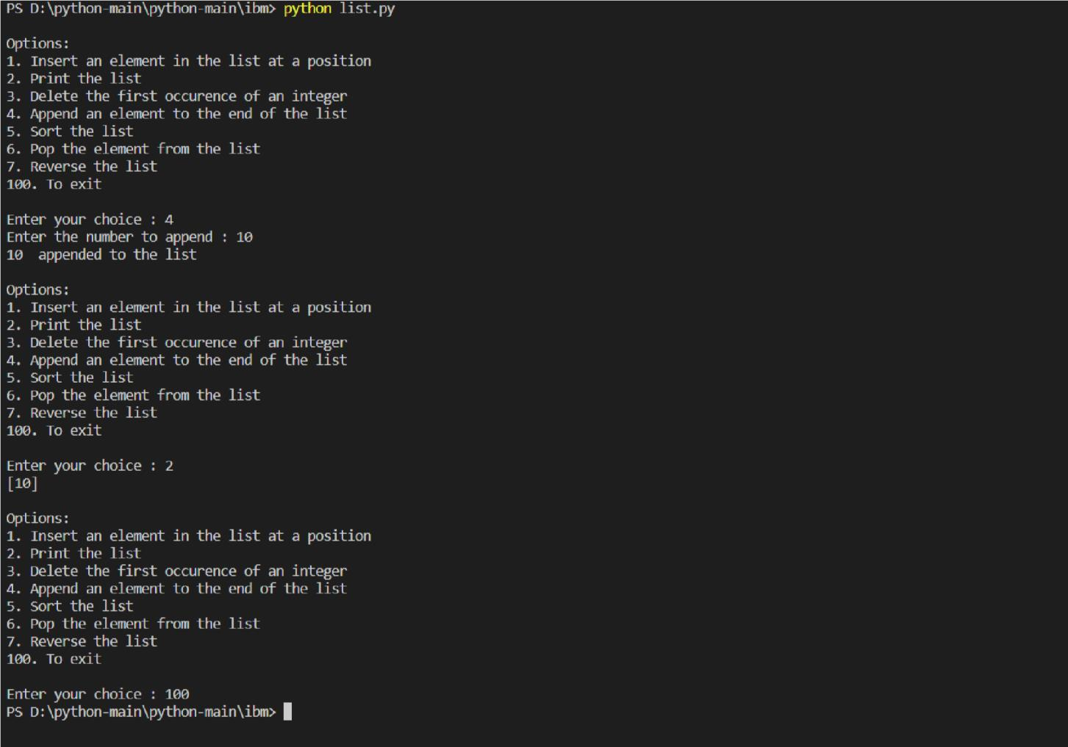

1. Calculatorprogram

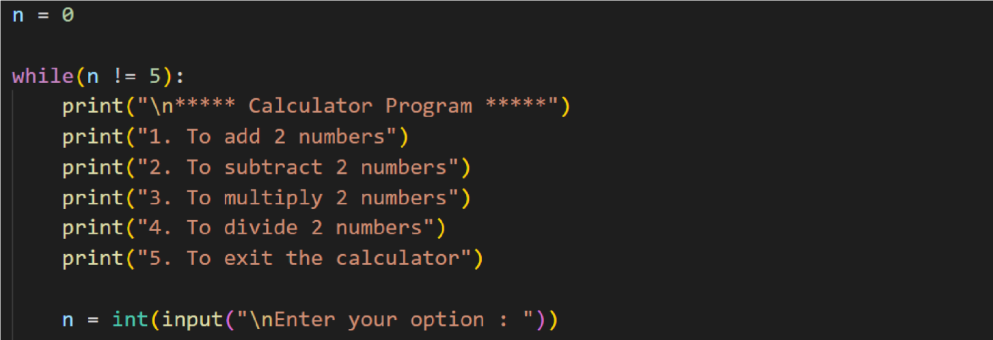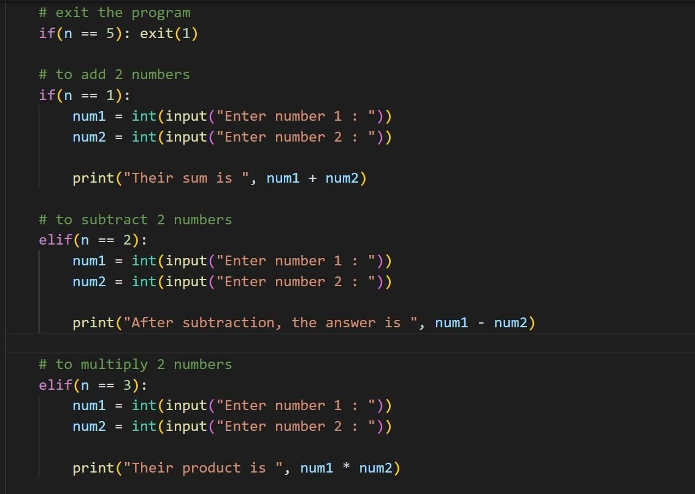

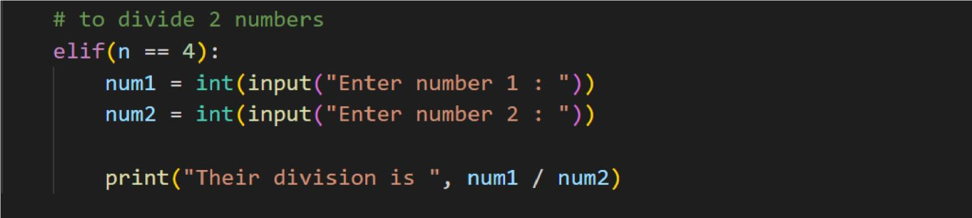

Output:

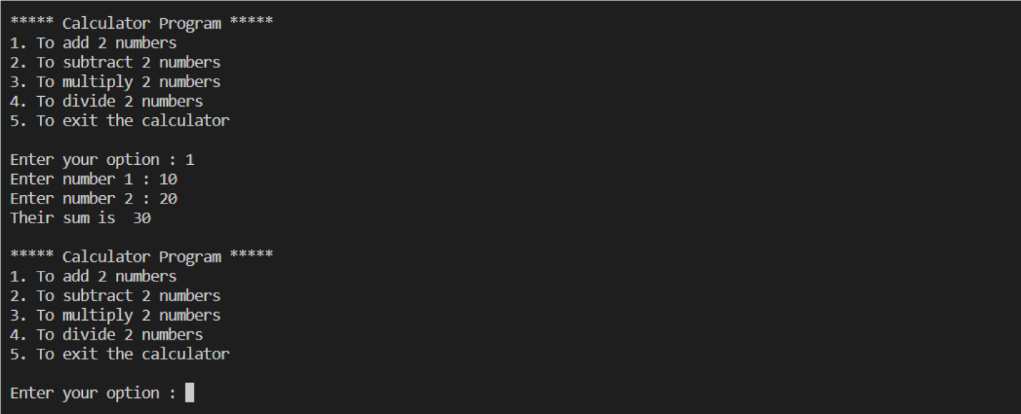

1. Stringoperations

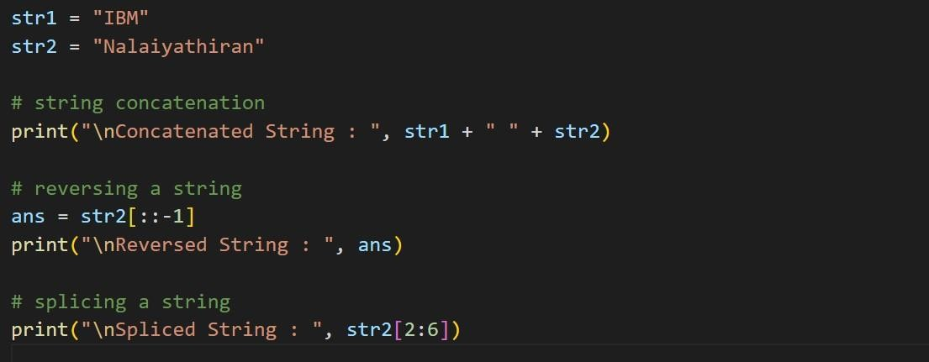

Output:

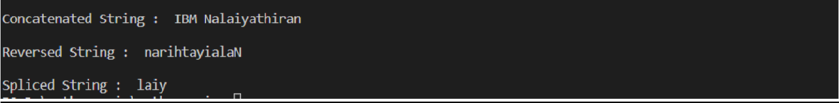

1. WhyisPythonapopularprogramminglanguage?
   * Beginner-Friendliness
   * Versatility
   * Awesomecommunityandresources
   * AutomationSoup
   * Pythonworks withIOT
   * BigcompaniesusePython
   * ImageProcessing
   * GraphicalAnalysis
   * NaturalLanguageProcessing
   * MachineLearning
   * ArtificialIntelligence
   * Greatlibraries andframeworks
     + Numpy
     + Matplotlib oSciPy oDjango oBeatifulSoup
2. Whataretheframeworksthatcanbeused withpython?
   * Flask
   * Bottle
   * Django
   * Web2py
   * AIOHTTP
   * CherryPy
   * Dash
   * Falcon
3. Fullformof WSGI?

A **Web Server Gateway Interface** (WSGI) server implements the web server side ofthe WSGI interface for running Python web applications. Why is WSGI necessary? Atraditional web server does not understand or have any way to run Pythonapplications.

**Submitted by**

1. Sabari Shree R
2. Varsha K P
3. Sudhan I
4. Krishnakanth G V